IDOX Enterprise and Capability Review
Project Scope

Document Control
Summary
Project name | IDOX Enterprise and Capability Review
Project Name | IDOX
SRO | Paul Hussey
Project Manager | Angie Johnson
Author | Angie Johnson, Charles Doherty
Date | 27/09/19
Version Control
Version | Date | Author | Change Description
1.0 | 27/09/2019 | Angie Johnson, Charles Doherty | First Draft
2.0 | 26/10/2019 | Charles Doherty | Updated to include feedback from the Director of Planning and Property and the Director of Neighbourhoods and Development
3.0 | 07/11/2019 | Charles Doherty | Updated following creation of Cabinet Report

Background and context
IDOX software applications are currently used by several departments to provide both back office functionality, and front facing client applications. As part of the councils Digital to Improve Programme it is proposed to initiate a project to review, and expand on the capabilities offered by IDOX, and further consolidate other systems into the IDOX Uniform solution. This will provide benefits both in terms of back office efficiencies and benefits to residents.

Currently the below IDOX solutions are used within the council:

Uniform
- Planning – including TPOs, Appeals, Enforcement, Listed Buildings
- Building Control – including Dangerous Structures, Competent Person Scheme, Demolitions
- Environmental Health – including Accident Reports, Commercial Premises, Service Requests, Housing
- Estates – including Asset Register, Acquisition and Disposal, Valuations
- Local Land and Property Gazetteer - which uploads to the NLPG National Land and Property Gazetteer. Street naming and numbering

LALPAC
- Licensing – Private Hire Vehicle Licences, Hackney Carriage Licences, Premises Licences
TLC
- Land Charges, Constraints

IDOX Elections
- Elections, Canvassing, Electoral Register Management

It is proposed to consolidate the LALPAC Licensing system into Uniform. This will allow the utilisation of mobile applications by licensing for inspections and field work. Public Access will also provide residents with a more uniform online portfolio for accessing services.

It is also proposed to upgrade the existing Uniform system to include additional modules and functionality as below:

- IDOX Document Management System – To provide integrated document management and public access to documents
- IDOX Enterprise – To provide performance management, workflow and automation
- IDOX Data Management Tool – Providing Data Protection and GDPR compliance

Due to the intensive project management requirements necessary to deliver this project, it is proposed that a new post is created to act as project manager and system supervisor duties once the project has been completed and benefits realised. In line with the Digital to Improve Programme the SRO responsibility will fall under the Director of Customer and Digital. The newly created role will be funded from the Neighbourhoods and Development or Planning and Property directorates and will consolidate the system supervisor responsibility from each service area using Uniform into this role. It should be noted that the Environmental Health System Supervisor role is currently vacant and will be replaced by the new role if approved.

Whilst this project is included within the Digital to Improve Programme as its own entity. There are several other projects which will be beneficially impacted by the delivery of this project including:
- Agile working (Including culture and process improvement)
- Paperless Office
- Security and Compliance
- System consolidation
- Integration and Automation
- Document Management

The services using the new functionality will also benefit from improved process management and KPI monitoring, removal of manual processes reducing risk of error, increased mobile working and data provision for statutory service work.

Project Scope
As detailed within the Digital to Improve Programme this project will essentially undertake an IDOX capability review and rationalise systems where appropriate, as well as introducing additional modules and functionality. The IDOX Document Management System will modernise the document management process and deliver workplace efficiencies whilst offering benefits to the customer. Aligning core systems such as the intention to migrate Lalpac into IDOX will provide benefits to officers and reduce the training need by removing additional systems.

Regulatory services such as Planning, Environmental Health and Licensing will benefit from strict process controls and measures, to allow cases to be processed and tracked in line with agreed service level agreements, and allow KPI’s and measures to be tracked and reported more accurately.

It is proposed to consolidate the LALPAC Licensing system into Uniform, which will allow the utilisation of mobile applications by licensing for inspections and field work. Public Access for Licensing will also provide residents with a more uniform online portfolio for accessing services.

It is also proposed to upgrade the existing Uniform system to include additional modules and functionality as below:

  - IDOX Document Management System – To provide integrated document management and public access to documents
  - IDOX Enterprise – To provide performance management, workflow and automation
  - IDOX Data Management Tool – Providing Data Protection and GDPR compliance

The services using the new functionality will also benefit from improved process management and KPI monitoring, removal of manual processes reducing risk of error, increased mobile working and data provision for statutory service work.

Within Scope
As part of the scope of this project each process which utilises the existing or proposed system will undertake a process mapping exercise to assist in post project benefits realisation as well as assisting in recognising areas to drive efficiencies.

Several new modules will be introduced including IDOX Enterprise, providing back office workflow, IDOX EDRMS providing document management and seamless integration with both back office and front facing client applications as well as the introduction of the IDOX Data Management Tool which will assist in the compliance with GDPR and Data Protection legislation.

The project will also look to consolidate a number of systems in order to simplify the ICT environment and ease future automations and integrations.

The below provides further detail of each of the key milestones within scope:

Undertake IDOX Health Check
The IDOX Health Check would utilise technical support by IDOX to review our current use of the system to compare both process and system functionality against best practice. The Health Check would also include consultation with key users and provide a written report detailing findings, recommendations for improvement and implementation suggestions. Each core module would require 2 technical support days at £950 per day plus an additional 1.5 days project management. In Total £9,025 would be required to review all core modules. The Health Check will also be used as an enabler to baseline any pre-requisites required to implement the other stages of the project.

The benefit of completing this health check prior to commencing the roll out of Enterprise is critical in assessing the current position, ensuring that the Foundations (i.e. all modules) are suitable before introducing IDOX Enterprise. Any priority remediation work should be performed relevant to the distinct modules prior to the introduction of IDOX Enterprise. Implementing new systems is an opportunity for transformation, and as a result ensuring that legacy hang-ups do not impair functionality is critical.

Introduce IDOX Enterprise
The introduction of IDOX Enterprise will have associated costs of £26,725 as an initial investment, followed by annual maintenance of £2,800 per annum. Initial investment costs will include software licences, associated services and training.

Whilst not baselined it is expected that efficiencies will be delivered in terms of time taken to process cases and the reduced need for manual routing of cases, which will be determined by the workflow. A benefits realisation study has taken place which has revealed the following benefits achieved by other local authorities using IDOX Enterprise (as well as other IDOX Uniform modules):

- 55% of applications received electronically
- £7,000 per annum saved on printing and postage
- 93% completion certificates issued within 5 working days (up from 78%)
- Positive environmental impact due to officers no longer needing to visit the office to access the IDOX system

Lincolnshire Building Control also saw an efficiency saving of approximately 170 hours per month on administration which was now automated as part of the IDOX Enterprise function.

Introduce IDOX EDRMS
During the councils Public Sector Network (PSN) accreditation process in 2019, it was highlighted that the current EDRMS web portal provided by Civica is out of date and requires upgrading to provide continued PSN compliance and reduce risk to the organisation. To continue using the Civica product or upgrade to a supported version of the Civica product, investment in the region of £15,000 would be required. If a migration to IDOX DMS for Planning was opted for there would not be a need to carry out the Civica upgrade. The costs associated with IDOX EDRMS are £63,850 as an initial investment with £4,380 annually.

Moving to IDOX EDRMS for Planning would reveal the following business benefits:
- Streamlined integration and workflow with IDOX Enterprise and other IDOX modules.
- Simplification of the overall landscape reducing IT management overheads.
- Simpler authentication and single sign-on, by being reliant on a single vendor’s systems, resulting in an improved user experience, reliability and efficiency.
- Support from a single vendor end-to-end for Planning resulting in improved supportability and efficiency.

It should also be noted that whilst the IDOX DMS require increased revenue when compared to the existing Civica DMS solution, the proposed solution will deliver document management capabilities to all services using IDOX whilst Civica only delivers document management capabilities to planning officers.

There would also be associated costs of approximately £20,000 to migrate the existing data from Civica to IDOX.

Consolidate Lalpac into IDOX Licensing

The proposal included within this project is to consolidate the existing Lalpac Licensing solution into Uniform. This will provide benefits for the licensing service by reducing manual back office functions, providing mobile and remote inspection and enforcement capabilities, as well as providing a single property view (Licensing, Environmental Health, and Planning history in one accessible location). There will also be benefits to external stakeholder by improving public access functionality and aligning this to the same look and feel as the Planning public access functionality.

The costs associated with this consolidation require an initial investment of £37,800 plus an annual cost of £16,543. This would be offset by a removal of the annual charge of £16,543 currently provisioned for the Lalpac licensing system.

Introduce IDOX Data Management Tool
Costs associated with this module will involve an initial investment of £9,250 including training, with a further £1,000 per annum for support and maintenance. Whilst no efficiencies are expected to be received from this investment, it is required to ensure compliance with GDPR and Data Protection. This will strengthen the Council’s compliance position with a positive impact on risk profile levels as data is being actively managed against known data protection legislation and GDPR cleansing rules.

Out of Scope
Whilst IDOX Elections and Total Land Charges are both provided by IDOX, under the scope of this project there will be no changes or updates to either system, this is due to both products sitting outside of the Uniform system and there being limited scope for additional functionality at this moment in time.

A further project within D2I scheduled for year three of the programme, will look to introduce electronic canvassing to support the councils agile and paperless ambitions.

Project Outcomes and Deliverables

Initiative | Key Outcomes
IDOX Health Check | - Ensure GDPR and Data Protection Compliance
IDOX EDRMS | - Compliance with Data Protection (GDPR)  - Improved Customer contacts and journeys  - Asset Management  - System rationalisation and Single Sign On
IDOX Enterprise | - Performance Management - Improved KPI recording  - Improve ways of working, enable officer time to be repurposed  - Simplified Workflow routing and automation
IDOX Mobile Applications | - Enable remote / Agile working  - Provide inspecting offices with necessary data in the field
IDOX Licensing | - System consolidation  - Enabler for Public Access for Licensing and Mobile Working  - Reduction of the number of logins required to users to access online portals
IDOX Data Management Tool | - Ensure GDPR and Data Protection Compliance
IDOX API (Application Programmable Interface) | - Provide an interface to interact with other council systems including the Firmstep CRM and provide automation facilities to increase efficiency within appropriate departments and services

Project milestones
The key milestones and completion dates will be:

Milestone | Completion date
EDRMS Installation & Configuration | December 2019 – April 2020 (Rollout for all departments)
Current System Health Check | January 2020
IDOX Data Management Tool Configuration | February 2020
Assemble Project Team and backfill posts if applicable | March 2020
Process map areas highlighted in Health Check | March 2020
Transfer Licensing department to IDOX | March – June (Including data migration)
IDOX Mobile Application Rollout | April 2020
IDOX Enterprise

Planning (including Enforcement, Appeals, TPOs) | July 2020
Building control (including Dangerous Structures and Reports) | September 2020
Asset Management | December 2020
Environmental Health | January 2021

Dependencies

There are no recognised dependent projects that will impact this work, however this project will deliver benefits that have been identified within other projects. For example, the Digital to Improve Programme recognises agile working and customer experience as key contributors to underpin the success of the programme. IDOX EDRMS and IDOX Public Access will consolidate the number of online portals available to residents and improve access to key data. IDOX Mobile applications will also enable agile working for services which have historically been restricted due to lack of available technology.

Shared Services Considerations

Whilst this project is being undertaken by South Ribble only, Chorley have already implemented IDOX Enterprise and IDOX EDRMS, and are a user of IDOX Licensing and Public

Access for Licensing. This project will further align the systems between both councils acting as an enabler for any future shared services.

Utilising Public Access for Licensing and IDOX EDRMS will also ensure that residents and businesses are familiar with the same systems between authorities providing benefits as the shared CMS project is delivered.

Cost / Benefit Analysis
There are costs associated with this project, however they will be on an invest to improve basis, or an invest to save basis. As each of the three project strands below can be implemented independently, costs have been separated to allow easier analysis:

IDOX Health Check
The IDOX Health Check would utilise consultancy by IDOX to review our current use of the system to compare both process and system functionality against best practice. The Health Check would also include consultation with key users and provide a written report detailing findings, recommendations for improvement and implementation suggestions. Each core module would require 2 consultancy days at £950 per day plus an additional 1.5 days project management. In Total £9,025 would be required to review all core modules. The Health Check will also be used as an enabler to baseline any pre-requisites required to implement the other stages of the project.

The benefit of completing this health check prior to commencing the roll out of Enterprise is critical in assessing the current position, ensuring that the Foundations (i.e. all modules) are good before building the metaphoric “house”. Any priority remediation work should be performed relevant to the distinct modules prior to the introduction of IDOX Enterprise. Implementing new systems is an opportunity for transformation, and as a result ensuring that legacy hang-ups do not impair functionality is critical.

IDOX Enterprise

The introduction of IDOX Enterprise will have associated costs of £26,725 as an initial investment, followed by annual maintenance of £2,800 per annum. Initial investment costs will include software licences, associated services and training.

Whilst not baselined it is expected that efficiencies will be delivered in terms of time taken to process cases and the reduced need for manual routing of cases, which will be determined by the workflow. A benefits realisation study has taken place which has revealed the following benefits achieved by other local authorities using IDOX Enterprise (as well as other IDOX Uniform modules). The North Yorkshire Building Control Partnership chose IDOX Uniform as their core back office system following a merger of 5 local authority building control services, the merger along with the implementation of IDOX Enterprise enabled the below efficiencies:

- 55% of applications received electronically
- £7,000 per annum saved on printing and postage
- 93% completion certificates issued within 5 working days (up from 78%)
- Positive environmental impact due to officers no longer needing to visit the office to access the IDOX system

Lincolnshire Building Control also saw an efficiency saving of approximately 170 hours per month on administration which was now automated as part of the IDOX Enterprise function.

IDOX EDRMS

During the councils Public Sector Network (PSN) accreditation process in 2019, it was highlighted that the current EDRMS web portal provided by Civica is out of date and requires upgrading to provide continued PSN compliance and reduce risk to the organisation. To continue using the Civica product or upgrade to a supported version of the Civica product, capital investment in the region of £15,000 would be required and also additional revenue of £1,600pa. If a migration to IDOX DMS for Planning was opted for there would not be a need to carry out the Civica upgrade. The costs associated with IDOX EDRMS are £63,850 as an initial investment with £4,380 annually.

Moving to IDOX EDRMS for Planning would reveal the following business benefits:

- Streamlined integration and workflow with IDOX Enterprise and other IDOX modules.
- Simplification of the overall landscape reducing IT management overheads.
- Simpler authentication and single sign-on, by being reliant on a single vendor’s systems, resulting in an improved user experience, reliability and efficiency.
- Support from a single vendor end-to-end for Planning resulting in improved supportability and efficiency.

It should also be noted that whilst the IDOX DMS require increased revenue when compared to the existing Civica DMS solution, the proposed solution will deliver document management capabilities to all services using IDOX whilst Civica only delivers document management capabilities to planning officers.

There would also be associated costs of approximately £20,000 to migrate the existing data from Civica to IDOX.

IDOX Licensing

The proposal included within this project is to consolidate the existing Lalpac Licensing solution into Uniform. This will provide benefits for the licensing service by reducing manual back office functions, providing mobile and remote inspection and enforcement capabilities, as well as providing a single property view (Licensing, Environmental Health, and Planning history in one accessible location). There will also be benefits to external stakeholder by improving public access functionality and aligning this to the same look and feel as the Planning public access functionality.

The costs associated with this consolidation require an initial investment of £37,800 plus an annual cost of £16,543. This would be offset by a removal of the annual charge of £16,543 currently provisioned for the Lalpac licensing system.

IDOX Data Management Tool

Costs associated with this module will involve an initial investment of £9,250 including training with a further £1,000 per annum for support and maintenance. Whilst no efficiencies are expected to be received from this investment, it is required to ensure compliance with GDPR and Data Protection. This will strengthen the Council’s compliance position with a positive impact on risk profile levels as data is being actively managed against known data protection legislation and GDPR cleansing rules. Costs involved in GDPR data breaches are extremely high and also have an adverse reputational impact, so investing in tools to strengthen the position is a worthwhile endeavour.

Project Costs
There are costs associated with this project, however they will be on an invest to improve basis, or an invest to save basis. Please see table 1 below which details full indicative costs associated with this project. It is proposed that the existing annual maintenance for the current IDOX Uniform system of £62,000 is re-negotiated as additional modules are introduced:

In considering alternative options is if we were to retain the existing Civica EDRMS this would require investment to both maintain and upgrade the Civica system. See table below. This option was therefore rejected as it would not be cost effective and would not deliver the benefits as cited in the project scope.

Initiative | Capital Investment | Current Revenue Investment | Proposed Revenue Investment
Civica Documents & Public Document Access | £15,000 (Upgrade would be required to existing system if IDOX route is not chosen) | £3,771.41 | £1,600.00 (Upgrade would be required to existing system if IDOX route is not chosen)

The table below details full indicative costs associated with this project.

Initiative | Capital Investment | Current Revenue Investment | Proposed Revenue Investment
Civica Documents & Public Document Access | £0 | £3,771.41 | £0
IDOX DDE Civica Link | £0 | £1,377.85 | £0
Lalpac | £0 | £16,543.00 | £0
IDOX Uniform existing modules | £0 | £60,622.15 | £60,622.15
Health Check | £9,025.00 | £0 | £0
IDOX Document Management System | £63,850.00 | £0 | £4,380.00
IDOX Enterprise | £26,725.00 | £0 | £2,800.00
IDOX Licensing | £37,800.00 | £0 | £16,543.00
IDOX Data Management | £9,025.00 | £0 | £1,000
Total: | £146,425.0 | £,82,314.41 | £85,345.15

As can be seen from the above once introduced there will be additional revenue requirements of £3,030.74 which will need to be added to the ICT Revenue Budget. The capital requirements of £146,425.00 could be allocated from the ICT capital fund drawing on future year’s provisions if required. In addition to the above it is expected that there will be costs to migrate data from the existing Civica EDRMS system to the new IDOX environment.

Benefits Realisation

As part of the scope of this project existing and ideal circumstance processes will be mapped for several reasons. Robust process maps will ensure that IDOX Enterprise can be configured to promote the most efficient and direct workflow, and will also support the post project benefits realisation review.

Two Environmental Health processes have been mapped pre-project which show the potential for efficiency savings through the introduction of IDOX Enterprise, IDOX EDMS, mobile applications, training and workflow automation. An example for commercial premises is shown below. A full suite of pre and post project process maps will be created as part of the scope of this project:

Current Process Flow

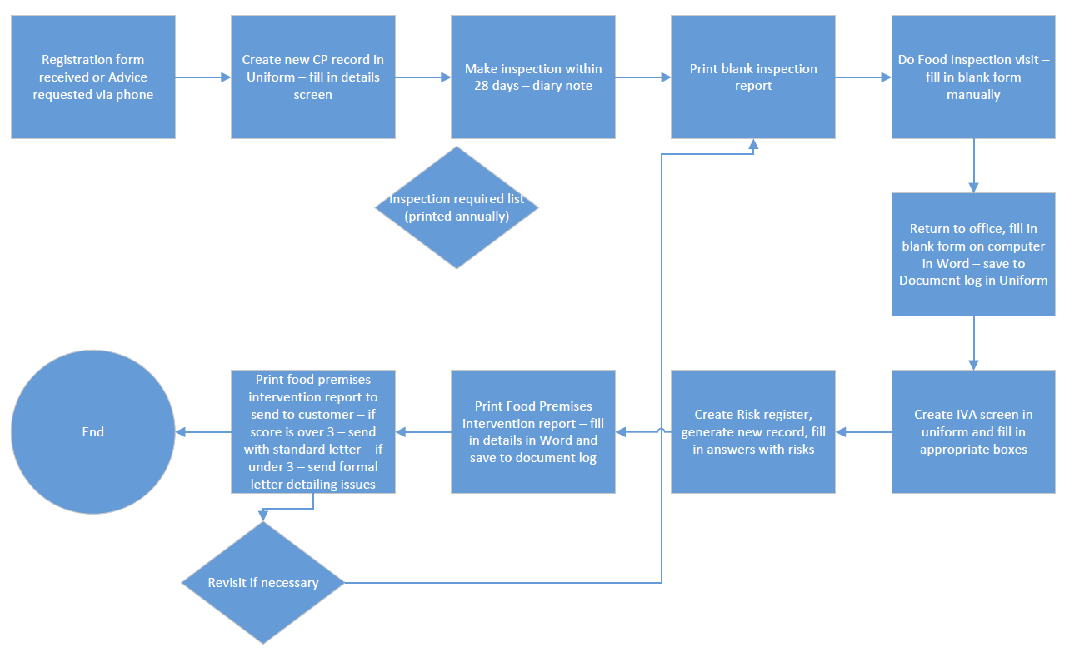

New Process Flow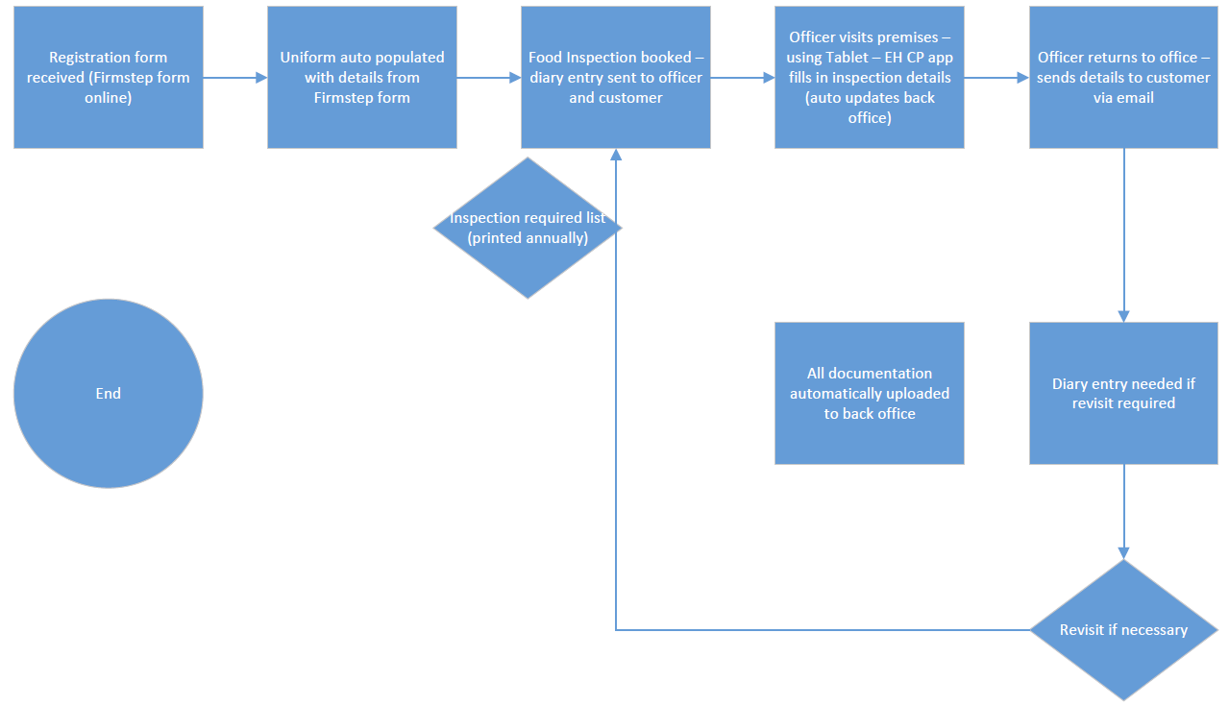

The initial estimated cashable efficiencies associated with the two environmental health processes amounts to approximately £10K. Once the new processes have been embedded it will be the responsibility of service leads to drive the efficiencies from their services and ultimately realise the benefits from the project.

The above process mapping exercise demonstrates the potential cashable efficiency savings that could be realised. Further work is required in this area however it is reasonable to assume that similar cashable efficiency savings could be realised in a number of other service areas potentially generating a further £40k in efficiency savings.

The North Yorkshire Building Control Partnership chose IDOX Uniform as their core back office system following a merger of 5 local authority building control services, the merger along with the implementation of IDOX Enterprise enabled the below efficiencies:

- 55% of applications received electronically
- £7,000 per annum saved on printing and postage
- 93% completion certificates issued within 5 working days (up from 78%)
- Positive environmental impact due to officers no longer needing to visit the office to access the IDOX system

The Project Team have spoken to other councils who have implemented IDOX Enterprise and DMS. Solihull Council implemented Enterprise and DMS in 2014 which enabled several key benefits, including:

- All Planning and Building Control documents to be fully digitised, creating a paperless service
- The reduction in paper and document storage also enabled the service to move to a smaller premises
- Enterprise is used to streamline the planning application process and assign tasks to officers more easily
- Performance can be monitored in real time to provide accurate KPI data amongst individuals or groups

Lincolnshire Building Control also saw an efficiency saving of approximately 170 hours per month on administration which was now automated as part of the IDOX Enterprise function.

Shared Services Considerations

Whilst this project is being undertaken by South Ribble only, Chorley have already implemented IDOX Enterprise and IDOX EDRMS, and are a user of IDOX Licensing and Public Access for Licensing. This project will further align the systems between both councils acting as an enabler for any future shared services. It is also proposed that any newly negotiated IDOX contract will be over an 18 month to 2 year period to align South Ribble and Chorley contract dates.

Utilising Public Access for Licensing and IDOX EDRMS will also ensure that residents and businesses are familiar with the same systems between authorities providing benefits as the shared CMS project is delivered.

Human Resources

There will be considerable process and culture changes through the introduction of IDOX Enterprise which will need to be supported through training and support. HR will be involved throughout this project and have been assigned a role on the project team to provide advice and support.

A new post has been proposed in line with the job description and person specification. HR will be required to undertake a job evaluation process and facilitate the creation of this post. It is proposed that this role is funded on a full time, permanent basis funded from existing resources and advertised internally to reuce the time taken to fill this role..

Whilst this project is being undertaken by South Ribble only, Chorley have already implemented IDOX Enterprise and IDOX EDRMS, and are a user of IDOX Licensing and Public Access for Licensing. This project will further align the systems between both councils acting as an enabler for any future shared services. It is also proposed that any newly negotiated IDOX contract will be over an 18 month to 2 year period to align South Ribble and Chorley contract dates.

Legal and Procurement

As the provisions included within the scope of this project can only be supplied by IDOX, and the associated costs fall under the EU threshold of £181,302 one procurement route would be to use a framework agreement which would allow a compliant direct award process. Alternatively a waiver of CPR rules would need to be obtained. As the value is over £100k the decision would need to go before Cabinet for approval.

In the circumstances that the contract value were to fall above the EU threshold, a negotiated procedure without prior publication would need to be considered. Legal would need to be comfortable with this approach and specific requirements as laid down in the regulations would need to be followed. If relying on this procurement route a VEAT notice may be published in OJEU to resist challenge on grounds of ineffectiveness under the Public Contracts Regulations 2015 Reg 99 (3).

Risks

Risks will be monitored in line with the councils adopted Risk Management Framework and entered into InPhase.

Risks will be logged using a 4x4 risk matrix rating likelihood again impact / severity:

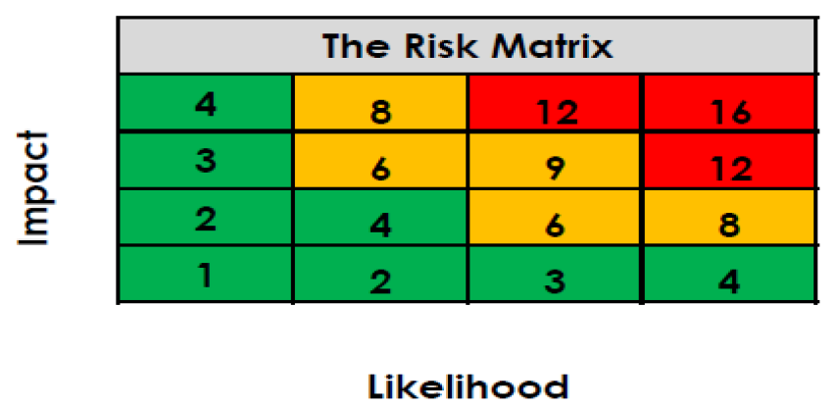

Project risks have been identified as below with initial estimated risk scores. Measures will be implemented to reduce risks where possible and within financial capacity. External risks will be mitigated with appropriate measures where possible:

Risk Description | Likelihood | Severity | Risk Score | Mitigation Measures
Project cannot be delivered within budget | 1 | 4 | 4 | Each project will be fully scoped before implementation ensuring that associated costs are highlighted and all stakeholders are aware. Where costs are likely to exceed budget this will be reported to the Digital to Improve Project board for decision making.
Project fails to deliver on key objectives | 2 | 3 | 6 | Key objectives have been defined ensuring that all project team members are aware of the required outcomes. A Communications Management Approach will be developed to ensure there are clear reporting lines to highlight any areas of potential failure early on in the process. Upon authorisation to initiate the project the project team will work with IDOX to review the scope and timelines in line with best practice and lessons learned.
Project cannot be delivered within estimated timeframe | 2 | 2 | 4 | The scope of the project has been clearly defined therefore reducing the risk of scope creep and delays to implementation. Key performance measures will be continually monitored with extra resources assigned where there is evidence of delays.
Project loses support of Leadership Team or Politicians | 1 | 4 | 4 | Regular updates will be provided to the Digital to Improve Project board with updates then taken to Corporate Planning Project Board. This should ensure that scope is always aligned to the Corporate Plan therefore maintaining support and political will.
Confusion regarding responsibilities and accountabilities | 2 | 1 | 2 | Key roles and responsibilities are and will be further defined within the scope so all members of the project team are aware of their key roles and responsibilities
Loss of SRO | 1 | 3 | 3 | The project is well defined which is hoped to ease the transition to a new SRO
Loss of Project Manager | 1 | 3 | 3 | The project is well defined which is hoped to ease the transition to a new Project Manager
Project scope creep | 3 | 2 | 6 | The project is well defined and it is hoped that whilst there may be slight changes to deliverables, there are no wholesale changes from the defined scope. A planned review will take place following the Health Check milestone to revise the project scope and introduce any applicable changes.
Low motivation within project team | 3 | 2 | 6 | As roles and responsibilities are clearly defined, it is hoped that motivation is maintained, although issues can be dealt with as they arise.
Health check unearths major challenges requiring further investment (time or financial) to resolve. | 3 | 3 |  | Build in contingency funding and time for in the event that additional resources are required to rectify.

Performance Management

Performance Management will be monitored, reviewed and improved, in line with the Digital to Improve Performance Framework, which was approved alongside the Digital to Improve Programme.

Progress will be reported to the Digital to Improve Programme Board who will also advise, and make any major decisions during implementation and planning. Progress will then be reported to the Corporate Planning Programme Board.

InPhase will be accessible to the SRO and Project Manager roles, as well as Project Support. This will allow for live progress reporting and provide commentary and updates on key milestones.

Proposed Key performance indicators have been identified, and whilst subject to change, will be used to evaluate the success of each individual project within the programme:

 | Key Performance Indicators (KPI) | Determine Via | Baseline | Polarity | Target
IDOX Enterprise | - % of applications processed in 8 or 13 weeks.  - Number and Type of applications per officer  - Number of KPIs available in real time  - Number of automated workflows  - Number of Appeals  - Number of Appeals Allowed | IDOX Enterprise Dashboard  IDOX Enterprise Dashboard  IDOX Enterprise Dashboard  IDOX Enterprise Dashboard  IDOX Enterprise Dashboard  IDOX Enterprise Dashboard | TBC | Higher is Better  Higher is Better  Higher is Better  Higher is Better  Lower is Better  Lower is Better | TBC
IDOX EDRMS | - Number of paperless processes  - Number of Public Access for Planning self service requests | Process Maps  Public Access for Planning / Google Analytics | TBC | Higher is Better  Higher is Better | TBC
IDOX Licensing | - Number of self service requests via Public Access for Licensing  - Time taken to process Licensing application | Public Access for Licensing / Google Analytics  IDOX Enterprise Dashboard | TBC | Higher is Better  Lower is Better | TBC
IDOX Mobile Applications | - Number of inspections / site visits undertaken  - Number of agile working enabled officers | IDOX Enterprise Dashboard  ICT Inventory & Mobile Device Management | TBC | Higher is Better  Higher is Better | TBC

Stakeholders and Communications Management

The below high level stakeholder groups have been identified, the Project Team will commit to working with these stakeholder groups and provide regular updates as the project progresses:

- Colleagues – Involving them in process mapping, training them and ensuring they get the best out of the computer system

- Members / Residents – Provide consistency in the way Planning and Licensing data is accessed and consolidate the number of logins required to access data online

- Partners / Suppliers – The Project Team will work with suppliers to implement the project.

Project Governance, Project Team and communications management

Initially, the below roles have been assigned prospective officers which are subject to change and approval:

SRO: Paul Hussey

Project/Project Lead: IDOX Project Co-Ordinator / System Supervisor

Technical Lead: Charlie Doherty, Sarah Masterson

Suggested Project Members: Sarah Kitchener, Lianne Mason, Sarah Masterson, Shannon Hill, Jade Dilworth, Stephanie Fairbrother, Kim Lamper, Steven Smith, Angie Johnson, Kevin Conway, Gail Collins

In line with the Digital to Improve Programme the SRO responsibility will fall under the Director of Customer and Digital. Due to the intensive project management requirements necessary to deliver this project, it is proposed that a new post is created to act as project manager and provide system supervisor duties once the project has been completed and benefits realised. The newly created role will be funded from the Neighbourhoods and Development and/or Planning and Property directorates and will consolidate the system supervisor responsibility from each service area using Uniform into this role. It should be noted that the Environmental Health System Supervisor role is currently vacant and will be replaced by the newly created role. Due to the current lack of capacity for IDOX system development, support and training, this role is required regardless of whether the IDOX Enterprise and Capability Review is undertaken.

The new post which has been proposed will include amongst other duties the delivery of this project in line with the agreed scope. Upon project completion and realisation of the anticipated benefits the newly created role will act as a system supervisor to provide continuous improvement in processes. A draft job description has been developed for this role and will be funded from within the Neighbourhoods and Development or Planning and Property directorates from existing budgets. Upon approval of the creation of this post HR will be requested to undertake an evaluation of the proposed job description and person specification to dictate the required grade for this role.

A ‘Train the Trainer’ approach will be taken to ensure that all officers are trained on any new software or functionality regardless of whether they are available for initial training.

The project will be managed in line with the councils Project Management Framework and all milestones and objectives will be monitored and reported on using the InPhase project management system. A series of exception criteria will be developed with the SRO in terms of time and costs to aid in the reporting process. Monthly highlight reports will also be provided to the SRO with progress regularly reported at Programme Board.

Similarly the associated risks will be entered into InPhase following the Risk Management Framework adopted by the council.

